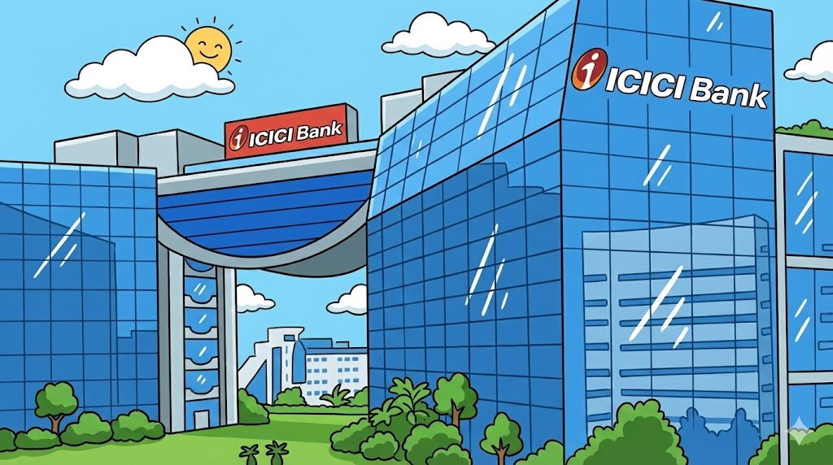

Company Overview:

- A joint venture between one of India's largest banks and a British multinational insurance and asset management company. Founded in 1993, ICICI Prudential is an India-focused financial services group, with ICICI Bank holding a 51% stake and Prudential Plc holding 49%. While ICICI Bank offers in-depth knowledge of Indian investment practices, Prudential Plc offers international, best-in-class asset management expertise. The joint venture helped access distribution networks in India backed by ICICI Bank. ICICI Prudential consistently ranks among the top five mutual fund houses.

- Their partnership has diversified into two companies, ICICI Prudential Asset Management Company and ICICI Prudential Life Insurance. The life insurance company was listed in 2016. Over the last decade, the share price has doubled, yielding a 108% return for shareholders.

IPO Background
- The IPO is an entirely offer-for-sale, an exit option for current shareholders. Proceeds from the IPO will not be used for operations, and total share capital will remain unchanged.
- Strong positioning of ICICI Prudential as a stable, profitable, and near-mature company creates an opportunity for value realization-87buy6xf. Over 4.89 crore shares of this listing are held by Prudential Plc, UK.
- Industry trends indicate the mutual fund industry is poised to grow. A growing customer base of retail investors and increased SIP inflows support this growth.
- For every investor in a mutual fund, there are another 19 individuals who have not. The Industry growth suggests increased investment practices in the future. Investors are drawn to the asset-light business model, which generates income through management fees.
- Furthermore, the integration of digital payments and UPIs has made mutual funds highly accessible and directly contributed to their success.

Structure of the Offer

- The issue size is ₹10,602.65 Cr, with a total offer-for-sale of 1,000,000,000 shares.
- The total shares offered are 48,972,995 at a face value of ₹1.
- The UK promoter, Prudential Plc, lists over 4.89 Crores.
- The Offer includes a reservation of up to 2,448,649 Equity Shares of face value of ₹1 each (constituting up to 5.0% of the Offer) aggregating up to million for subscription by Eligible ICICI Bank Shareholders.

Page 61

Competitor Landscape

- Among competitors such as SBI AMC, HDFC AMC, Nippon India AMC, and others, ICICI Prudential AMC is the current market leader in fund management, with a 13.3% market share.

- SBI AMC manages a higher volume of assets backed by government organizations and PSUs, which yield low returns.

- HDFC AMC manages a lower asset volume than SBI but charges a higher management fee, which supports its higher profitability.

- ICICI Prudential has a larger base of retail investors subscribing to regular plans, which boosts its market share and profitability. This data is supported by revenue from systematic transactions: 4800 Crores for ICICI and 4510 and 3640 Crores for HDFC and Nippon AMC, respectively.

- The average operating revenue yield of 0.52% is also a market leader. The primary competitors operate at margins of 0.36–0.48%.
Page 109

Financials

The total revenue of ICICI Prudential AMC has risen from 2838 Crores in FY 2023 to 4980 Crores in FY 2025, driven by management fee income.

- Net Profit show 32.2% growth, from 1516 Cr in FY23 to 2050 Cr in FY24 and 2651 Cr in FY 25.
- The EBITDA margin has remained constant at 73-74% in the previous three financial years.
- The company is also debt-free, which appeals to investors who prefer an asset-light model.
- The customer base is expected to grow to 1.5 Crore in FY 2026, representing a 53% increase over the last two years.

(Indian Rupees in Million)
Metrics | FY25 31st Mar 2025 | FY2024 31st Mar 2024 | Change(%)
Revenue | 49773.3 | 33582.3 | 48.23
Cashflow from Operation(CFO) | 25735 | 17645.4 | 45.85
EBITDA | 36369.90 | 27800.10 | 30.83
Net Profit/(Loss) | 26506.6 | 20497.3 | 29.32
Return On NW(%) | 82.80% | 78.90% | 4.94
EPS | 150.2 | 116.1 | 29.37
Page 224

Risks Associated

- ICICI Prudential faces intense competition in the mutual fund sector. The industry AUM rose from ₹13 Lakh crore to ₹75 lakh crore in 2025. However, ICICI Prudential holds just 13% of the market share. Competitive management fees drive the market share in this industry.

- The company operates in a highly regulated industry. SEBI regulates and revises the total expense ratio (TER), commissions, and product categorization rules. The industry is also prone to enhanced disclosure and compliance requirements. SEBI's focus on investor protection has constrained ICICI Prudential's pricing flexibility.

- There is a dependence on third-party mutual fund distributors and other banks. Inefficiencies within these companies could adversely affect ICICI Prudential's operations. The third parties are engaged for services including unit administration, fund accounting, payment gateways, IT and call centre services, Etc. The prospectus for the issue states that long-term agreements typically underpin these relationships and are subject to SEBI regulations. The company has a contingent liability of 143.8 Crores, but the impact is likely to be minimal due to the net profit of 2651 Crores reported in FY25.

Page 32

Conclusion

- The listing of ICICI Prudential highlights the success and growth of India's asset management industry and household financial participation.
- As the current market leader, the company is projected to deliver safe returns, offering a long-term, secure option for gains.

Authored By: Kailas Sunil, FLC

Disclaimer:

This article is intended solely for information and educational purposes and does not constitute any financial, investment or legal advice. The data and analysis presented are based on publicly available information, including the company’s Red Herring Prospectus (RHP) and reputable financial news sources. Readers are advised to conduct their own research and consult with a qualified financial advisor before making any investment decisions. The author and publisher have no responsibility for any monetary losses or damages from reliance on the information contained herein.

